Short googling revealed that this is a [relatively old graph from October 2017](https://www.visualcapitalist.com/63-trillion-world-debt-one-visualization/). On one hand, this is a really cool visualization. On the other hand, it also belongs to Facebook pages such as [Trust me, I’m a Statistician](https://www.facebook.com/TrustMeImAStatistician) or [Trust me, I’m a Data Scientist](https://www.facebook.com/TrustmeImaDataScientist/).

What do we see?

This is a kind of a [pie chart](https://en.wikipedia.org/wiki/Pie_chart). In a classic pie chart, the slices are in the form of “triangles”, or more precisely, circular sectors. In this chart the slices have other forms, including various types of triangles and quadrilaterals, other polygons, and shapes that I really don’t know their names. [2]

I admit that this chart pretty confused me. It presents national debt and Debt/GDP ratio data. Initially I referred to the Debt/GDP ratio, and for some reason I thought that the area of ​​each slice in this chart represents Debt/GDP ratio of each country, probably because my eye first caught the chart’s footer.

Actually, each slice shows the share of the country’s national debt out of the world’s total debts, so the areas of all pieces should sum to 100% [3]. We see clearly that the country with the largest share of debt out of the total world national debts (and therefore the highest absolute debt) is the United States. The country with the second largest share of debt is Japan, and China is third. Look for Italy, Germany, France and the United Kingdom. Can you determine which of the four states has a bigger share of the total debt by looking just at the area of their slices? Actually, their shares of the total debt are very similar.

The Debt/GDP ratio of each country is expressed by the color of its slice. The lighter the color, the higher the Debt/GDP ratio. You can immediately see that Japan has the highest Debt/GDP ratio, and I believe that most people will recognize that Greece also has a very high Debt/GDP ratio, actually the second highest ratio. Can you spot the country with the third largest ratio? It is Lebanon.  Look at the upper right area of the chart. Italy and Portugal, which occupy fourth and fifth place, are more prominent. Can you tell which country has the lowest Debt/GDP ratio?

Now that we understand the data presented in this graph, we can start looking for insights.

This chart is a two-dimensional chart, in the sense that it presents two different variables in the same graph. Such graphs are useful for exploring the relationship between the two variables. So, what is the relationship between the Debt/GDP ratio of a country and its share in the world’s total debts? Can you see anything? I can’t. It is to the credit of the authors that they did not try to discuss this matter at all.

Is there a better way to visualize these data? Of course there is. Let’s play.

I took the [world’s Debt/GDP ratio data](https://en.wikipedia.org/wiki/List_of_countries_by_public_debt#Public_debt_as_%25_of_GDP)  and [the world’s GDP data](https://en.wikipedia.org/wiki/List_of_countries_by_GDP_(nominal)) from Wikipedia. For the purpose of the demonstration, I focused on the OECD countries data from 2017. I calculated the absolute debt of each country using the Debt/GDP ratio and the GDP data, and then I calculated for each country its share of the total OECD debt. The data are available [here](http://www.sci-princess.info/wp-content/uploads/oecd.txt).

The simplest possible visualization for two dimensional data is a [scatter plot](https://en.wikipedia.org/wiki/Scatter_plot), although it is not as cool as that pie chart. Let’s forget what we learned by looking at that pie chart, and start from scratch.

This code generates a basic scatter plot of the OECD data:

plot(c(0,250), c(0, 40), axes=FALSE, type="n", xlab="Debt/GDP ratio (%)", ylab="% Share of Debt", main="", cex.main=1)

axis(1, 50*(0:5),cex.axis=0.8)

axis(2,at=10*(0:4), las=1, cex.axis=0.8)

points(oecd$debt.gdp.ratio, oecd$share.of.debt, type="p", pch=16, cex=1, col="black")

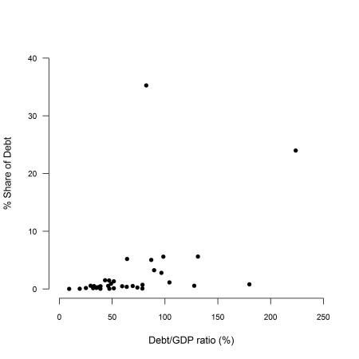

The plot clearly shows that there are two outlier dots/countries; One country has Debt/GDP ratio greater than 200%. Another country has an awfully large debt – its share of total OECD debt is higher than 30%.

A closer look reveals a country whose Debt/GDP ratio is greater than 150%, and two more countries whose Debt/GDP ratio is about 130%.

Since some economists who believe that high debt is bad, and that high Debt/GDP ratio is even worse, I decided to divide the countries into three groups: [4]

* The first group includes the countries with either Debt/GDP ratio which is greater than 100% **or** their share the total debt is greater than 10%. These are countries that are in “bad” economic situation according to these parameters.
* The second group includes the countries whose Debt/GDP ratio is less than 50% **and** their share the total debt is greater than 2%. These are countries that are in “good” economic situation according to these parameters.
* The third group includes the rest of the countries.

I decided to paint the dots that represent the countries which are in “bad” economic situation in red, and to add their names on the graph. I painted the dots that represent the countries which are in “good” economic situation in green. The rest of the dots are painted in orange.

This code generates the improved scatter plot:

w1=which(oecd$debt.gdp.ratio>100 | oecd$share.of.debt>10)

w3=which(oecd$debt.gdp.ratio<50 & oecd$share.of.debt<2)

w2=which(!(1:36 %in% c(w1,w3)))

plot(c(0,250), c(0, 40), axes=FALSE, type="n", xlab="Debt/GDP ratio (%)", ylab="% Share of Debt", main="", cex.main=1)

axis(1, 50*(0:5),cex.axis=0.8)

axis(2,at=10*(0:4), las=1, cex.axis=0.8)

points(oecd$debt.gdp.ratio[w1], oecd$share.of.debt[w1], type="p", pch=16, cex=1, col="red")

text(x=oecd$debt.gdp.ratio[w1],

   y=oecd$share.of.debt[w1],

   labels=oecd$country[w1],

     pos=4, cex=0.7)

points(oecd$debt.gdp.ratio[w2], oecd$share.of.debt[w2], type="p", pch=16, cex=1, col="orange")

points(oecd$debt.gdp.ratio[w3], oecd$share.of.debt[w3], type="p", pch=16, cex=1, col="green")

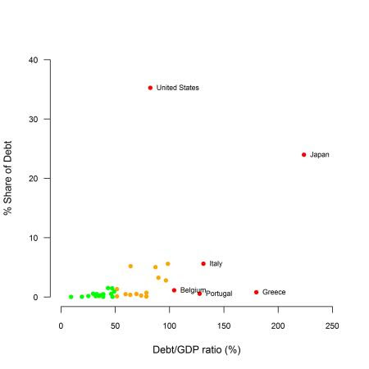

Now we can see that:

* The Debt/GDP ratio of the “good” states extends over the entire zero to 50% range, although the Debt/GDP of many countries in this group is close to 50%.
* The orange painted countries (the “middle” group) are roughly divided into two subgroups. The countries in the first subgroup have lower debts (as expressed by percent share of the total debt) and a Debt/GDP ratio in the range of 50 to 75%. The five countries in the second subgroup have higher debts , with no clear pattern for the Debt/GDP ratio.
* I cannot draw a general conclusion regarding the 6 countries which are in “bad” economic situation according to my definitions.

**Comments**

[1] I did some minor edits to the graph for the purpose of my demonstration.

[2] Look for the United Kingdom at the bottom of the chart, for example.

[3] I didn’t check any of the data. I trust the authors that the date is accurate.

[4] I chose the cut points of 10%, 100% etc. according to my best judgment. If you know an economist who has a more accurate method to determine such cut points, please introduce him to me.